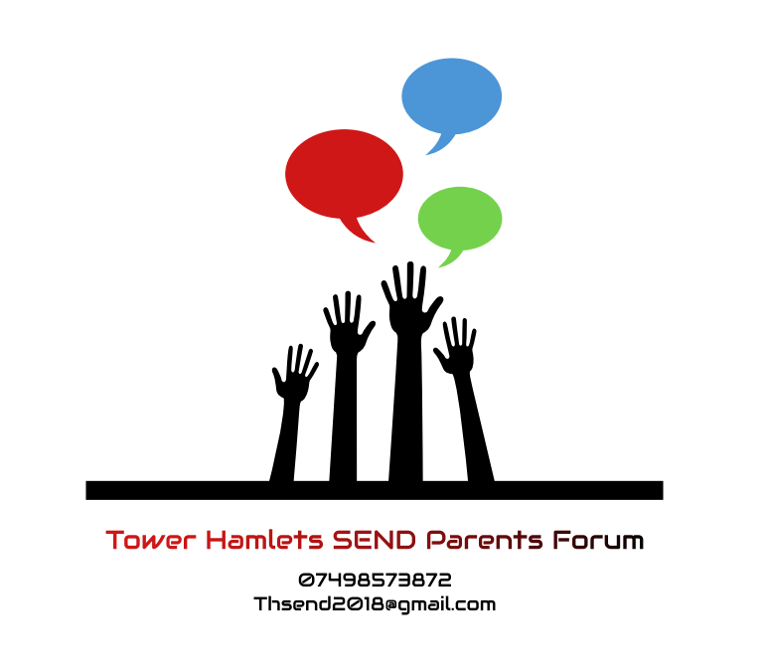

Terms of reference for Tower Hamlets Independent SEND Parents’ Forum and the Tower Hamlets Independent SEND Parents’ Forum steering committee

Purpose
The Tower Hamlets Independent SEND parent’s forum aims to be a voice to inform service providers and Local Authorities of the needs of children with Pan Disabilities and their families.
It will facilitate two–way communication between parent carers and services used by disabled children, young people and their families in Tower Hamlets. The forum will work to provide feedback on services, offer constructive challenge to current services and input into decision making and planning for future service provision.
The parent forum believes that by working co-operatively with local service providers parents can contribute to improvements in the services delivered for disabled children.
- Through regular communication with parent/carers’, ensuring they are able to decide whether to be involved in a piece of work/consultation.
- Ensuring a diverse forum membership and representation of diverse views from disabled children and parent/carers’ from all backgrounds and sectors of the community.
- Promoting a reputation and image of the Tower Hamlets Independent SEND parent’s forum which reflects its aims and values.

Tower Hamlets Independent SEND parent’s forum terms of reference
Membership
The Tower Hamlets Independent SEND parent’s forum membership will be made up of residents of Tower Hamlets who are parents/carers of a child with a disability, aged 0 to 25

Meetings
Tower Hamlets Independent SEND parent’s forum meetings will be held every 6 weeks where possible. Via zoom under current Covid -19 Conditions,
Any parent/carer of a disabled child living in the Tower Hamlets can put an item on the agenda by contacting the steering committee at thsendforum@gmail.com
Service providers will be invited to attend Tower Hamlets Independent SEND parent’s forum meetings as appropriate.
Information should be provided in a range of ways and formats to support the engagement of a wide number of parents and carers.
Words and terminology used in documents that are circulated at meetings, presentations and discussion should be free of jargon and abbreviations so that no one is excluded from participating.
Members may be nominated to sit on working groups set up by service providers. Members sitting on such working groups will feedback information to the main parent forum meetings. All members taking on a ‘representative’ role will sign a Parental Representation Agreement Form.
Parent reps names and details of areas of expertise they represent will be publicised so parents know who is representing them.

Tower Hamlets Independent SEND parent’s forum steering committee terms of reference
The business of the Tower Hamlets Independent SEND parent’s forum will be managed by the steering committee.

Membership
Ideally steering groups members should be no more than 12 and no less than 6
Members will stand for election annually.
A chair, secretary and treasurer will be elected from the Tower Hamlets Independent SEND parent’s forum steering committee’s membership.
A member can resign from the Tower Hamlets Independent SEND parent’s forum steering committee at any time, by putting this in writing to the chair.
A member who has not attended four meetings consecutively without giving apologies will be asked to stand down.
Each member will be responsible for representing the views of a wider group of parents. Thus each member should have a system of networking and disseminating information to other parents.
A parent wishing to be a member of the Tower Hamlets Independent SEND parent’s forum steering committee will produce a personal statement detailing how they would be representative of other parents.
There should be a place on the Tower Hamlets Independent SEND parent’s forum steering committee for specialist workers representing smaller community’s groups e.g. Travellers, Somali Community. This specialist worker/s will have been nominated by each particular group of parents.
All members of the Tower Hamlets Independent SEND parent’s forum steering committee will agree to and sign these Terms of Reference.

Meetings and feedback
The Tower Hamlets Independent SEND parent’s forum steering committee will meet on a regular basis – at least every six weeks. Via Zoom Under current Covid -19 Conditions, This can be changed if there is a need to meet more often.
Venues and meeting times will be arranged for the convenience of parent carers. Meetings will be during term time. (Currently Via Zoom)
There should be a quorum of no less than 1/3 of members present for a decision to be made.
The steering committee recognises that there will be differences of opinion and priority between members. Decisions will be made by consensus where possible, or where not possible, by majority.
Members will be entitled to claim reasonable expenses for travel incurred to attend particular meetings.
Information to be presented at the meeting must be circulated in good time prior to the meeting in order that members have timely access to information.
The Tower Hamlets Independent SEND parent’s forum will provide feedback to its membership through regular emails and the Tower Hamlets Independent SEND parent’s forum website This will include outcomes from consultations and participation work undertaken, and in particular the effect on future service provision.

Terms of reference will be reviewed once a year – next review date. April 2021
Date: April 2020
Signed:
 | Name | Signature | Position
1. | Samantha Gager |  | Chairperson
2. | Tuwahid Begum |  | Treasurer
3. | Marie McLeod |  | Voting Member
4. | Lisa Cassidy |  | Voting Member
5. | Jo Kelman |  | Voting Member
6. | Abigail Smith |  | Voting Member
7. | Neherun Ali |  | Voting Member
8. | Lynette Smith |  | Voting Member
9. | Frances Jones |  | Voting Member
10. |  |  | Voting Member
11. |  |  | Voting Member
12. |  |  | Voting Member

