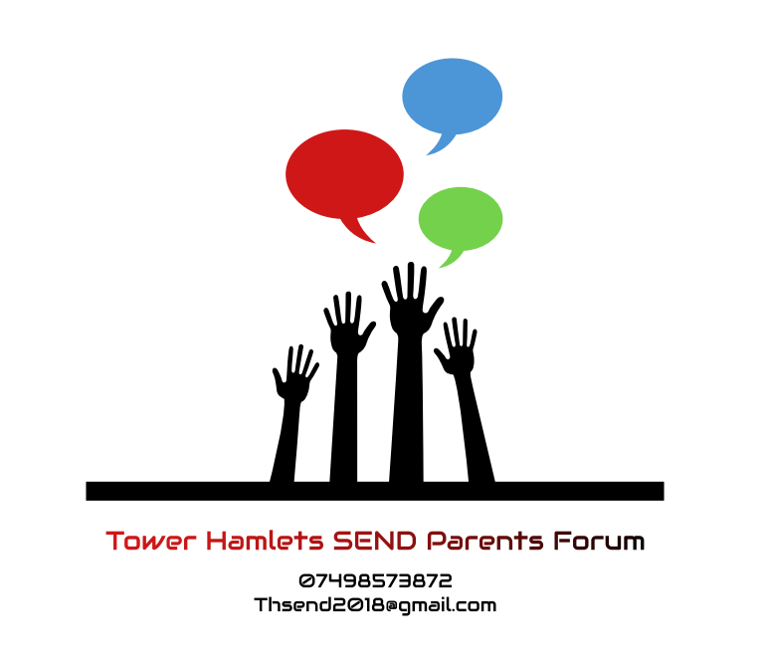

Tower Hamlets Independent SEND Parents’ Forum
DATA PROTECTION POLICY

Tower Hamlets Independent SEND Parents’ Forum will fully comply with the Data Protection Act 1998 and Data Protection principles, which state that information must be:

- Fairly and lawfully processed
- Processed for limited purposes
- Adequate, relevant and not excessive
- Accurate
- Not kept longer than necessary
- Processed in accordance with individuals rights
- Kept secure
- Not transferred without adequate protection

Tower Hamlets Independent SEND Parents’ Forum recognise that the above principles relate to both paper and electronic systems of record keeping.

This information will not be disclosed to any other party, unless with specific permission of the person it relates to. Any person may request that their details are removed from our records at any time. Any person may request a copy of their information at any time.

The membership database may not be e-mailed under any circumstances and will be held on a system with encrypted access.

The membership database may only be held by named members of the Steering Group or staff who have signed this form.

I agree to abide to the principles and rules of this policy.

Signed ---------------------------------------------------------

Position----------------------------------------------------------

Date---------------------------------------------------------------

